**Chloe Koh, 2124434 REPORT**

**USER GUIDE**

**Login Page**

Students login with their name and ichat password.

**Home page**

Upon Login, students will see this home page, where important announcements and dates are shown. The button on the top left is the ‘More button’.

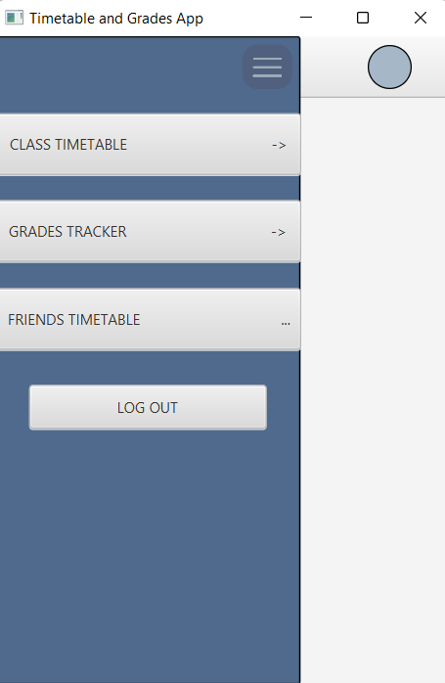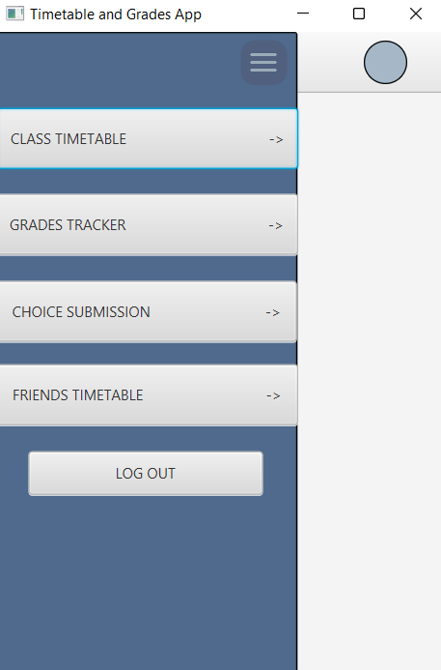When students click onto the ‘More button’, a page that allows them to choose what they want to do will appear. The task each student can do on the app is different. In every class, only the class rep and assistant class rep gets to choose the timing for timetable on behalf of the class. Thus, only the class rep and assistant class rep gets to see the ‘CHOICE SUBMISSION’ button, as shown on the left picture. While, other students will only the ‘CLASS TIMETABLE’, ‘GRADES TRACKER’, ‘FRIENDS TIMETABLE’ and ‘LOGOUT’ buttons as shown in the picture on the right.

The picture on the right appears when the students click on the ‘CLASS TIMETABLE’ button. This page shows the timetable of the student’s class. If the student clicks on the ‘More button’ again, they will be brought to the previous page. And if the student clickes on the ‘Choices’ button, students will see the next picture.

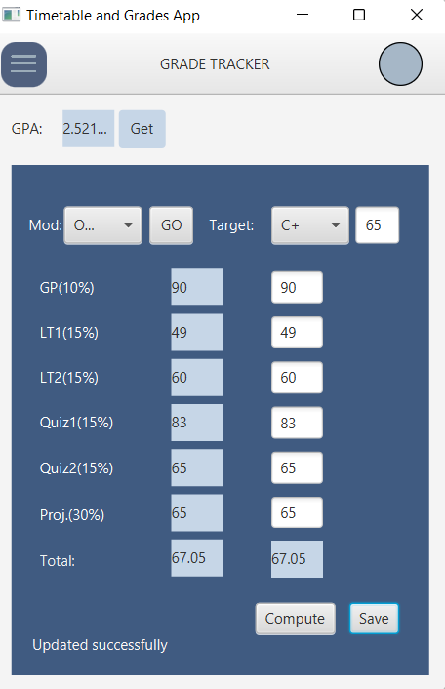 The picture on the left shows the different days and timings available for each module. Every student is able to view this to discuss and decide as a class the preferred timing for each lesson. When the ‘Timetable’ button is clicked, student will be brought back to the page as shown in the previous picture.

If the ‘GRADES TRACKER’ is clicked, the page on the right will be shown. The first combo box selects the output, it can either be, OOP, DSA, SAE, CINTER or DEVOPS module. The weightage and saved grades shown will differ for each module. Students can key in each of their results according to each weightage and click the ‘Compute’ button to get total. They can choose to save their results by clicking on the ‘Save’ button. The second combo box selects grades from A all the way to D for students to set their target and know the score they need.

To know their overall GPA for this 5 modules, students can click on the ‘Get’ button at the top.

To Logout, student can choose click on the ‘Logout’ button or the cross at top right of the window. Both will have a pop-up window to confirm log out.

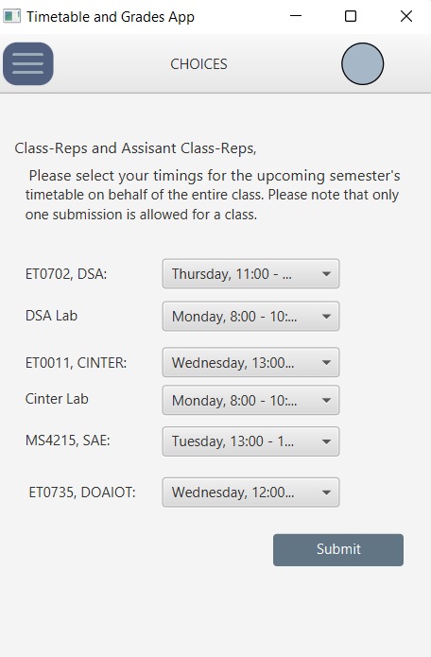The picture on the right shows the page of the

‘CHOICES SUBMISSION’ page. Students will choose the timings they want and click on the submit button. The result will be reflected to their ‘CLASS TIMETABLE’ page.

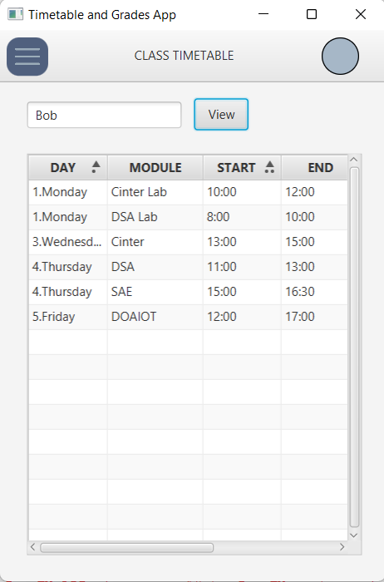The page on the left shows the friends timetable. Enter friends name in the text filed and click in view. Timetable of the friend will be show.

**Classes**

* 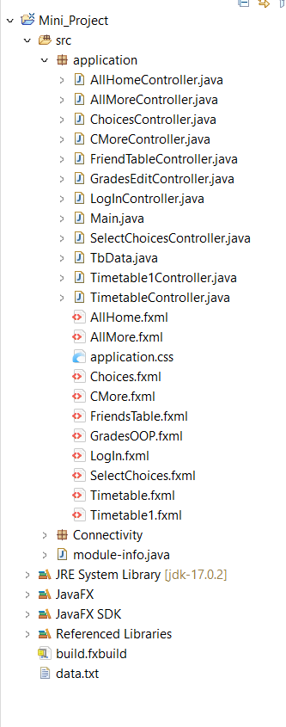Main

Is to start the program

* LogInController

For students to login, login() function is created to check for username and password entered. Only correct username and password is allowed to enter. Opens up home page when login successful

* AllHomeController

Homepage opened, onMoreClicked(ActionEvent event) function created to move to the next page, different page is opened for students who are class rep.

* AllMoreController

Opened up by AllHomeController, findclass() function created to open up the right timetable for students of different classes. onClassClicked(ActionEvent event) function calls the findclass() function to open up the right fxml. onGradesClicked(ActionEvent event) function clicked to open up the GradesOOP.fxml. onMoreClicked(ActionEvent event) function is to move back to the previous window, which is AllHome.fxml. onLogoutClicked(ActionEvent event) function have an alert pop-up when the logout button is clicked on.

* CMoreController

This class inherit from AllMoreController, the additional function is onChoiceClicked(ActionEvent event) which opens up the window for class rep or assistant to submit choices.

* FriendTableController

This class inherit from AllHomeController to get back to one of the MoreController page according to student signed in. Initialise() and initialise1() functions are created to retrieve data from two different tables according to the class of the friend being searched for. onViewClicked(ActionEvent event) is to search for friend and call respective function to view timetable.

* TimetableController

This class inherit from AllHomeController to get back to one of the MoreController page according to student signed in. It also implements initializable to initialise the tableview.

* Timetable1Controller

This class inherit from AllHomeController to get back to one of the MoreController page according to student signed in. It also implements initializable to initialise the tableview.

* TbData

A constructor is created to easier create object. The variables are all used to store and get details from the database

* SelectChoicesController
* This class inherit from AllHomeController to get back to one of the MoreController page according to student signed in. It also implements initializable to initialise the combo box to view the items. ObservableLists created to add items into combo box. Insert(String day, String mod, String start, String end, String lec, String loc) function is created to insert timing into the class timetable. onSubmittedClicked(ActionEvent event) is created to call the insert function.
* ChoicesController

This class inherit from AllHomeController to get back to one of the MoreController page according to student signed in. onBackController(ActionEvent event) function brings the user back to the timetable page

* GradesEdit Controller

This class inherit from AllHomeController to get back to one of the MoreController page according to student signed in. It also implements initializable to initialise the combo box to view the items from the database. onGetClicked(ActionEvent event) is to get the calculated gpa using the saved grades in database and the gp(int t) function. gp(int t) function is created to calculate the gpa for the modules. Functions like calOOP() and calcOOP() is created to set the weightage and calculate the grades. onGoCliked(ActionEvent event) is to set the module, showing the weightage and previous grades saved in database. onComputeClicked(ActionEvent event) calls for functions starting with calc to calculate the grades entered in text field. onSaveClicked(ActionEvent event) updates the newly calculated data into the database.

**UML Diagram**

